

**Green University of Bangladesh**

**Department of Computer Science and Engineering (CSE)**

**Faculty of Sciences and Engineering**

**Semester: (Spring, Year:2022), B.Sc. in CSE (Day)**

**Assignment - 01**

**Course Code: MAT 101**

**Course Title: INTEGRAL CALCULUS**

**Section: DJ**

**Assignment Topic: Integration**

**Student Details**

| **STUDENT NAME** | | **ID** |
| --- | --- | --- |
| **1** | **Jahidul Islam** | **221002504** |

**Submission Date : 15Th April, 2022**

**Course Teacher’s Name : Ms Samiha Islam Tanni**

**[For Teacher’s use only: Don’t Write Anything inside this box]**

| **Assignment Status**  **Marks: ………………………………… Signature:.....................**  **Comments:.............................................. Date:..............................** |
| --- |

**INTRODUCTION**

This assignment considers a number of problems in graph theory. A graph is an abstract mathematical structure formed by a set of vertices and edges joining pairs of those vertices. Graphs can be used to make connections between objects.

For example, **a computer network can be modelled as a graph** with **each server represented by a vertex** and **the connections between those servers represented by edges**.

Many problems in graph theory involve colouring, that is, assignment of labels or “colours” to the **edges** or **vertices** of a graph.

* These problems fall into two categories:
* The first type of problem concerns the possibility of assigning colours to a graph while respecting some set of rules.
* the second concerns the existence of coloured structures in a graph whose colouring we do not control.

**DEFINITIONS AND NOTATION**

A graph is defined by its vertices and its edges. For a given graph G, we use **V (G) to denote its vertex** and **E(G) to denote its edge**s.

* We use **Kn to denote the complete graph** on **n** vertices, which means that, the graph has **n** vertices including all possible edges.
* We use **Cn to refer to the cycle** on n vertices.
* Lastly, we use **Pn to denote the path** on n vertices but will refer to such a path as having

length n - 1, that is, the length of a path P, denoted |P|, will be equal to the number of its edges.

**GRAPH COLOURING**

Graph coloring is an assignment of a color to either each vertex or each edge.

Therefore, there are two types of graph coloring;

These are:

* **Vertex colouring:**
  + Assigning coloring to Vertex’s of a particular graph. A vertex-colouring is called proper if no two adjacent vertices are assigned the same colour.
* **Edge coloring:**
  + Assigning coloring to Edges of a that graph. An edge-colouring is called proper if no two edges of the same colour meet at a vertex.

A (proper) k-colouring is a (proper) colouring using at most k colours. A multi-colouring is a colouring where multiple colours may be assigned to each edge or vertex.

**CHROMATIC NUMBER**

A graph can be colored by assigning a different color to each of its vertices. However, for most graphs a coloring can be found that uses fewer colors than the number of vertices in the graph.

Here comes the Chromatic number.

* Definition: **The *chromatic number* of a graph is the least number of colors needed for a coloring of this graph.**

Problem 1: What is the minimum number of colours required to properly colour a given graph G?

* Solution: The chromatic number of a graph *G* is denoted by **χ(G)**. (Here *χ* is the Greek letter *chi)*.
  + For vertex-colouring, the minimum is called the chromatic number *χ*(G) of G
  + For edge colouring, the least chromatic index *χ* ‘(G) of G.

**THE FOUR COLOR-THEOREM**

* Theorem: **The *chromatic number* of a planar graph is no greater than four.**

b e 

a d g

c f

Figure 1: the simple graph G

Problem 2: What are the chromatic numbers of the graphs *G* shown in Figure 3?

* Solution: The chromatic number of *G* is at least three, because the vertices *a, b,* and *c* must be assigned different colors. To see if *G* can be colored with three colors, assign red to *a*, blue to *b*, and green to *c*. Then, *d* can (and must) be colored red because it is adjacent to *b* and *c*. Furthermore, *e* can (and must) be colored green because it is adjacent only to vertices colored red and blue, and *f* can (and must) be colored blue because it is adjacent only to vertices colored red and green. Finally, *g* can (and must) be colored red because it is adjacent only to vertices colored blue and green. This produces a coloring of *G* using exactly three colors. Figure 4 displays such a coloring.

b-Blue e-Green

a-Red d- Red g-Red

c-Blue f-Blue

Figure 2: Coloring of the Graph G

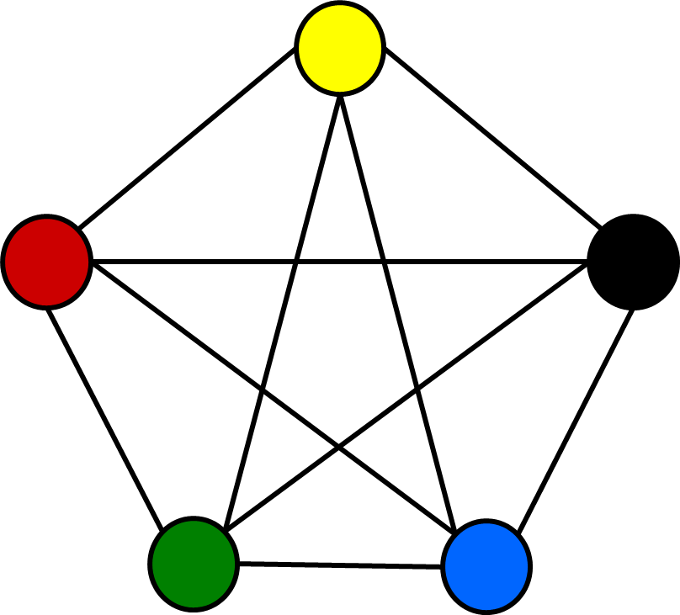

Problem 3: What is the chromatic number of *Kn*?

* Solution: A coloring of Kn can be constructed using n colors by assigning a different color to each vertex. A coloring of K6 using five colors is shown in Figure 5.
  + **Is there a coloring using fewer colors**? The answer is no. No two vertices can be assigned the same color, because every two vertices of this graph are adjacent. Hence, the chromatic number of Kn is n. That is, χ(Kn) = n. (We know that, Kn is not planar when n ≥ 5, so this result does not contradict the four-color theorem.)

The End